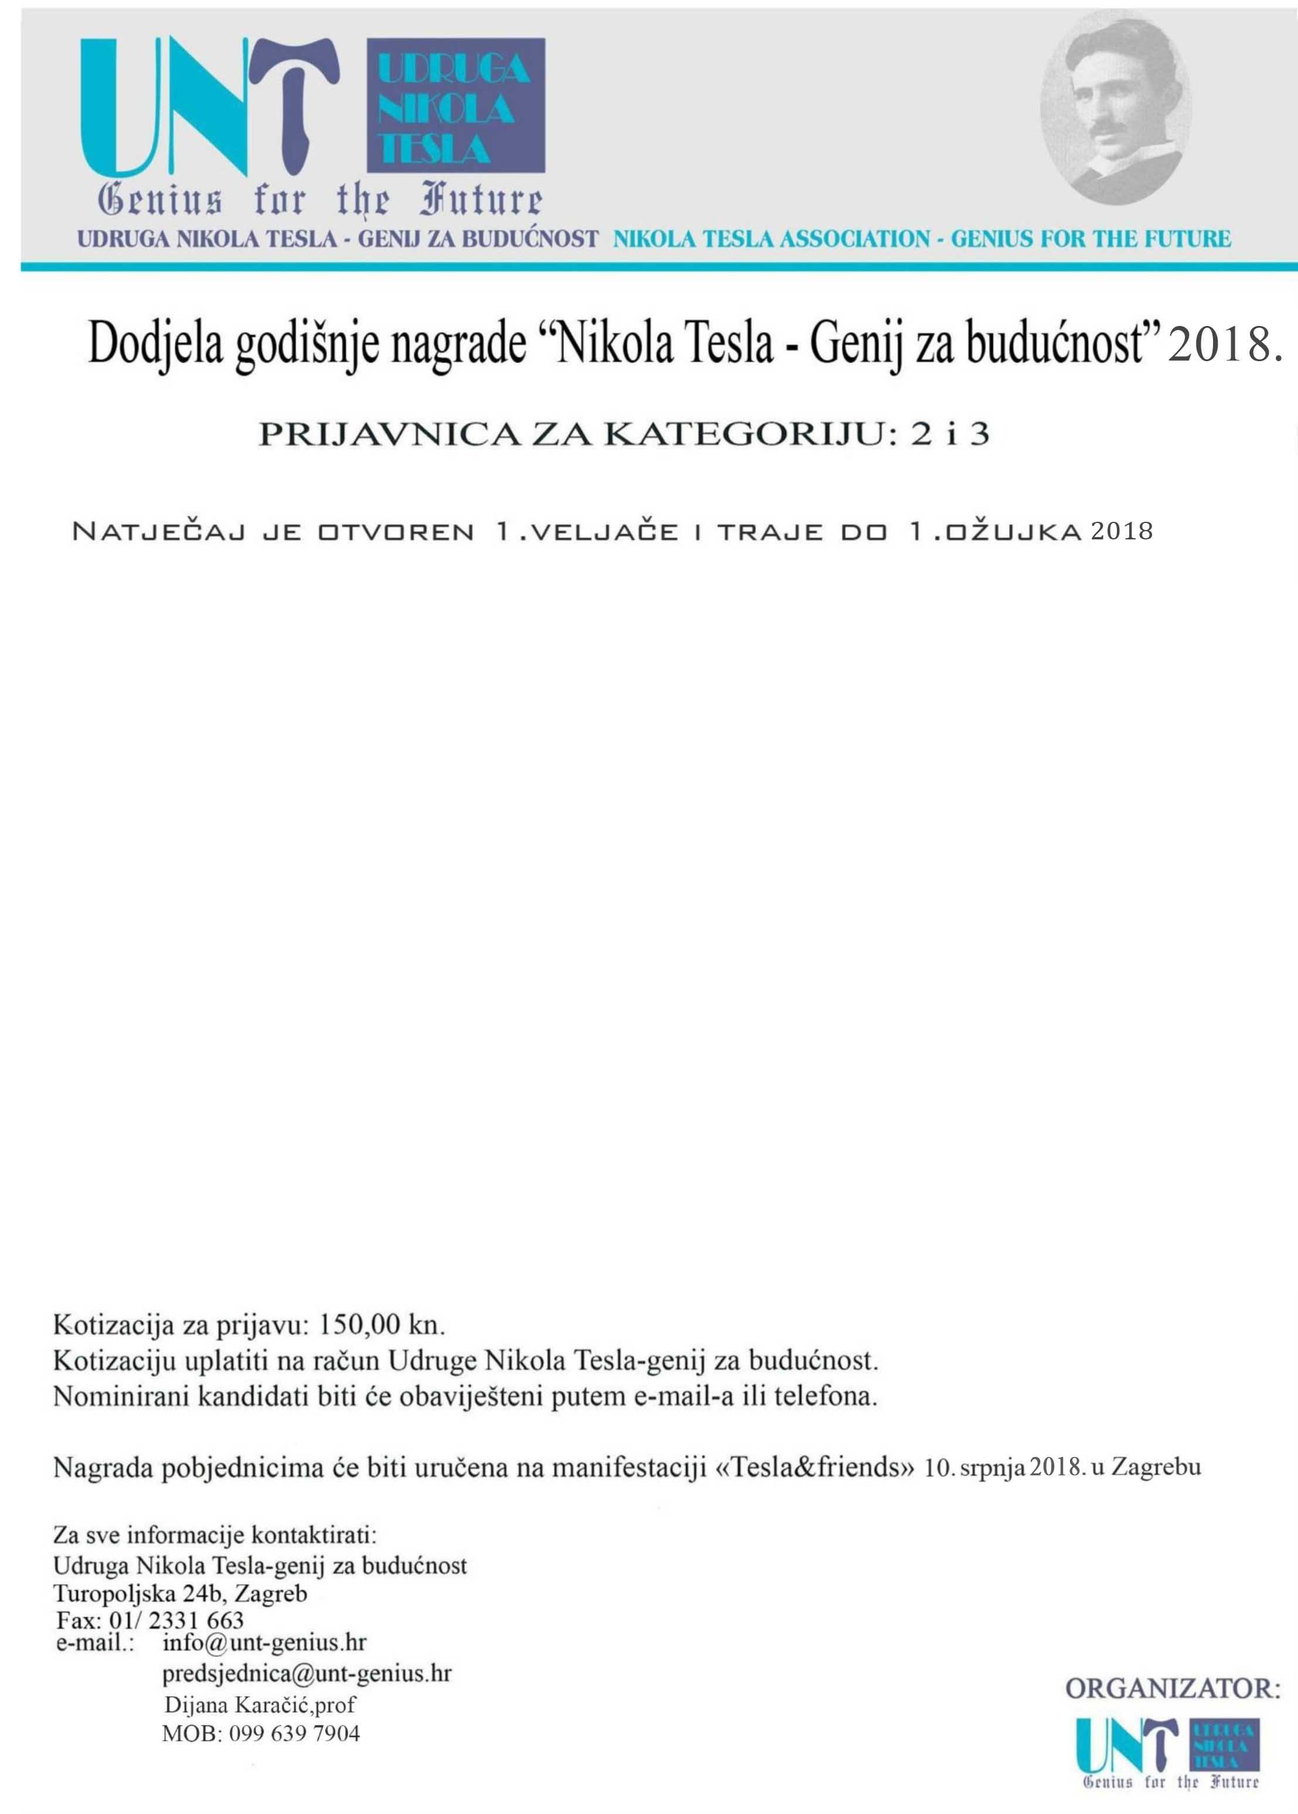

KATEGORIJA: ___________________________________________________________________________
SKUPINA:______________________________________________________________________________
NAZIV PROJEKTA:________________________________________________________________________
KRATAK OPIS PROJEKTA/PROIZVODA:________________________________________________________
_____________________________________________________________________________________
NOSITELJ PROJEKTA:
- FIZIČKA OSOBA:_______________________________________
IME I PREZIME:_______________________________________
ADRESA:_____________________________________________
- TVRTKA/UDRUGA:_____________________________________
KONTAKT OSOBA:_____________________________________
AUTOR PROJEKTA:_____________________________________

grad/poš.broj:________________________
tel/fax:_____________________________
email:_______________________________
mob:_______________________________

